Electromagnetics

Vector Fields

Vector functions have magnitude and direction at every point in space and are visualized by field lines.

The divergence of a vector function measures its outward spreading. The curl of a vector function measures its rotation.

Electrostatics

Electrostatics involves stationary charge distributions.

The force on a test charge due to another charge 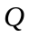displaced by is given by Coulomb’s Law

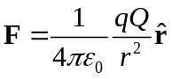

where is the unit vector along the line of separation and 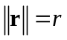. The electric field 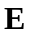is independent of the test charge and is given by

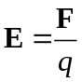

For a distribution of charges the electric field at positiondue to the charge distribution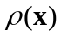is given by the superposition over a region (line, area, volume) in space

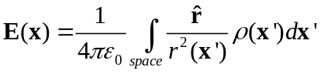

where 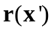is the displacement vector from the point 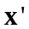to the differential charge element 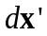.

Gauss’s Law

The net flux of electric field lines through any closed surface enclosing total charge 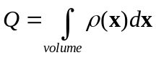 in free space is

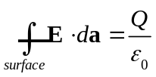

where 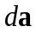is a surface element and 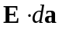is the flux (perpendicular field lines) through the element. From the divergence theorem

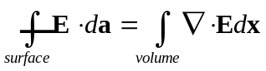

we may write in differential form as

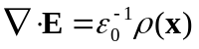

As an example let us compute the E-field for a uniformly charged sphere centered at the origin with total charge and radius 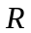. Since the differential area elements are always normal to the flux lines and since by symmetry the field is constant, we have

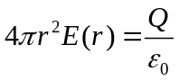
for 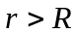and

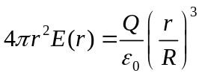

for 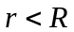because now only a fraction of the total charge is enclosed and the charge outside contributes no net flux. Therefore

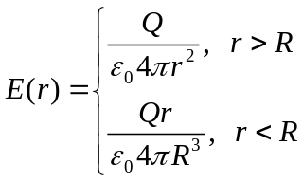

where the direction is implicitly along the radial line between the origin and the point at distance r. In the first case the sphere acts exactly like a point charge.

There are many times of Gaussian surfaces which exploit symmetries, for example cylindrical and pill-box surfaces.

If a dielectric is present then the E-field is decreased and is accounted for by changing 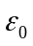to .

Electric Potential

The E-field is a special kind of vector function because its curl is always zero

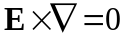

which leads to the definition of the scalar potential function 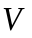measured in volts

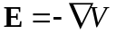

or as potential difference between two points a and b,

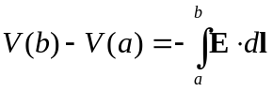

where the reference level is taken at 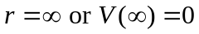 and is any path between.

As an example we compute the potential at a distance for a spherical shell of radius and with uniform surface density and total charge . The E-field is that of a point charge outside the sphere and zero inside because there is no net flux (it is a point charge so field lines enter and exit equally). The potential outside the sphere then is

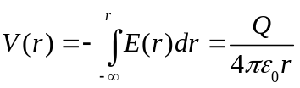

and inside is

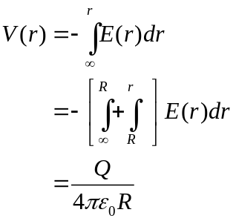

Hence, the potential at all points is

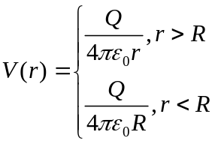

which goes as 1/r as opposed to the E-field which decays as 1/r^2. For a distribution of charges the potential is

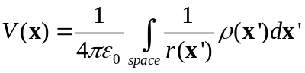

Maxwell’s Equations

Ampere’s Circuital Law

Ampere’s Law relates the current through a surface bounded by a closed loop or curve and is

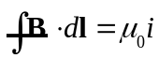

where the integral is around a closed “Amperian” loop and is the current enclosed in the loop and passing through the surface. By Stoke’s theorem which relates a loop integral to a surface integral, its differential is

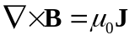

where is the current density and 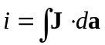. However, moving charges are not the only source of a magnetic field, as for example between the plates of a capacitor. This necessitates the addition of a term known as the displacement current density

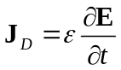
so that and become

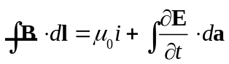
and

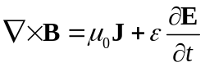

Thus, even for no current (J=0) a time varying E-field will by accompanied by a B-field.

Faraday’s Induction Law

Faraday’s Law states that the magnitude of the electromotive force (emf) 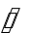 induced in a conducting loop is equal to the rate at which the magnetic flux 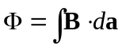 through the loop changes with time:

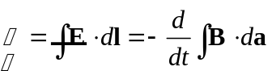

By applying Stoke’s formula we may write in differential form as

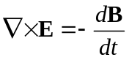

Therefore a time varying magnetic field will have an electric field associated with it. For example, a charge moving in a static B-field will experience a force

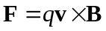

But its motion is relative so a stationary charge in a moving B-field must also experience a force. Yet whenever a charge experiences a force there must be an E-field present. Hence both a changing B-field and an electric field must be present. The relationship between them is given by Faraday’s Law.

Gauss’s Law for Magnetic Fields

This law says that magnetic monopoles do not exist in nature, i.e. the magnetic flux through a closed surface is always zero because there is always a source (“plus magnetic charge”) and a sink (“minus magnetic charge”). In this way what ever flux enters the surface must leave in order to terminate on the sink. This stated formally as

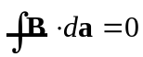

The equations , , together with form Maxwell’s equations, which, together with the Lorentz force describe virtually all of classical electrodynamics.

Maxwell’s Equations
( no free charge or current,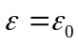 for free space)
Name | Differential Form | Integral Form | Description
Gauss’s Law | 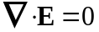 | 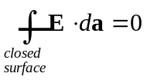 | Net electric flux through a closed surface is zero if the surface contains no free charge
 | 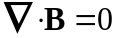 |  | No monopoles, i.e. field lines terminate on N/S, i.e. what comes in must go out, i.e. no net flux
Faraday’s Inductive Law | 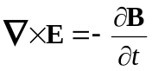 | 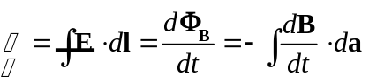 | A changing magnetic field induces an electric field
Ampere’s Law with Maxwell’s correction | 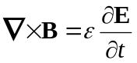 | 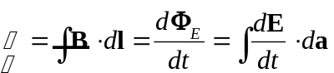 | Motion is relative, hence a changing B or E field will be accompanied by an E or B field

Maxwell’s Equations
(In linear media with free charge, i.e. a conductor)
Name | Differential Form | Integral Form | Description
Gauss’s Law | 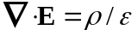 |  | Net electric flux through a closed surface is zero if the surface contains no free charge
 |  |  | No monopoles, i.e. field lines terminate on N/S, i.e. what comes in must go out, i.e. no net flux
Faraday’s Inductive Law |  |  | A changing magnetic field induces an electric field
Ampere’s Law with Maxwell’s correction | 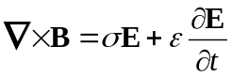 |  | Motion is relative, hence a changing B or E field will be accompanied by an E or B field

Propagation of Electromagnetic Waves

In regions of space where there is no charge or current Maxwell’s equations constitute a set of coupled partial differential equations for E and B. Once they are decoupled their components satisfy the scalar wave equation

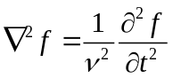

where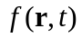is a transverse traveling wave with speed 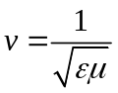 if the medium is linear and homogenous. In a vacuum the speed is the speed of light 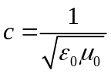. Typically 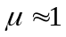and we shall mostly neglect its presence. Unless otherwise noted we assume a linear (frequency has no harmonic components), homogeneous (material is the same type), isotropic (properties of the medium do not change with direction) medium.

The wave equation may be derived from Maxwell’s equations in differential form as follows:

Take the curl of (), substitute in for () and then use the identity 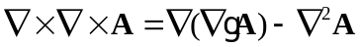for a vector field A to obtain

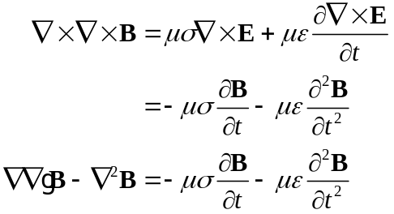

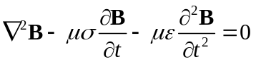

which is the wave equation for the magnetic field in a linear isotropic medium. To obtain the wave equation for the E-field, begin with (), take the curl, use the identity, and then substitute in () to yield

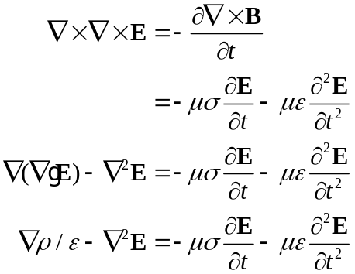

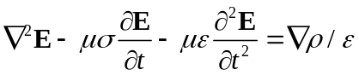

Free Space

The equation of the electric field of a monochromatic plane wave with time frequency and spatial frequency 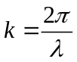 propagating in the direction is

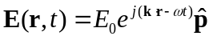

where is the polarization direction which is the orientation of the wave along its direction of travel and 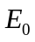is a complex amplitude. The B-field is perpendicular and the direction is determined by the right handed vector cross product.

The wave carries energy with it in the form of a flux density (energy per area per time) given by the Poynting vector

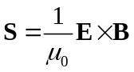
The average energy in the wave is

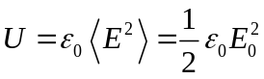
and the intensity (power/area) is

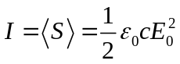

Media

When the wave travels through a medium the speed becomes

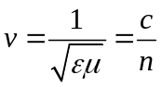

i.e. the free space quantities are replaced by medium variations.

Dielectrics

The boundary conditions of Maxwell’s equations give rise to Snell’s Law

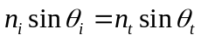

where the angles (in first quadrant so 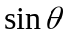 is monotonic increasing) are measured wrt to the normal to line in the plane of incidence. Thus if the wave is traveling from a lower index medium to a higher index medium 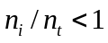 and thus 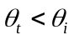and the wave direction will be refracted toward the normal.

The electric field amplitudes of the transmitted and reflected wave are related by the Fresnel equations

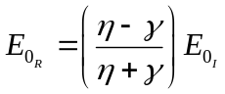

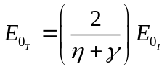

where 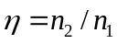and 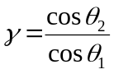. Thus the reflected wave may undergo a 180 degree phase shift if 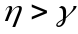. The intensities of the transmitted and reflected waves are related by

transmission and reflection coefficients

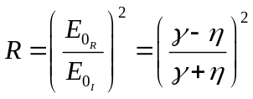

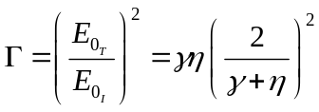

And 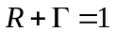by conservation of energy.

Conductors

Conductors contain free charge of volume density 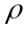which move subject to Ohm’s law

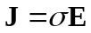

where is the coefficient of conductivity. Maxwell’s equations then assume the form given in Table (). The continuity equation for free charge is

From the continuity equation the density of free charge decays as

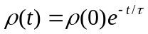

where 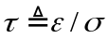is the time constant. For perfect conductors and the free charge is dissipated instantaneously. The wave equation derived from this set of Maxwell’s equations involves a complex wave number

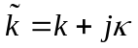

which depend on the frequency of the incident wave. The electric field vector in the conductor is

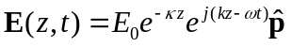

and thus we see that the field decays with distance into the conductor. Furthermore, the electric and magnetic field vectors are no longer in phase.

Waveguides

Fourier Optics

